You Are My Cinderella
January 28, 2017

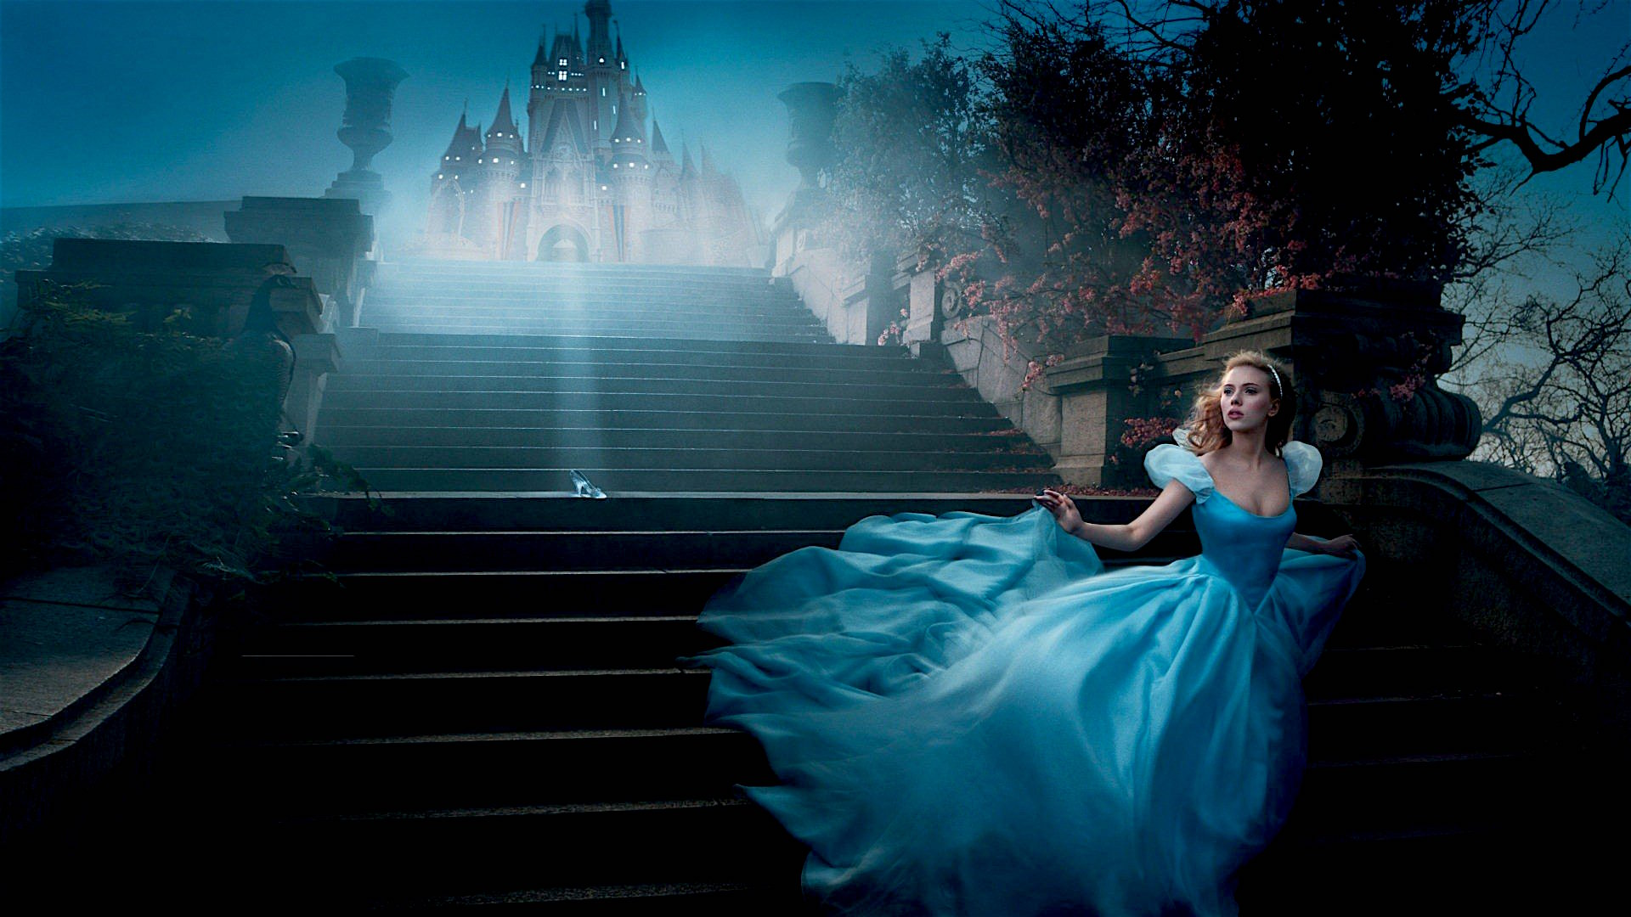
May we be inebriated with the Lord's love and pour that love out on the lost and wounded humanity living all around us, Heartdwellers.

Although this message begins where Jesus is addressing me, later on He makes it clear that what He has said to me applies to each of you in a very un-duplicatable way. You are one of a kind taken directly from the Father’s bosom and to have you return is unspeakable joy and bliss to your God.

Oh Lord, Your presence is so sweet this morning. You are so vulnerable!

He began, "That’s how I feel about you, My Bride. Even as you were musing…you are My Cinderella. There is not another in Heaven or on Earth like you. And to have you back in My arms is for Me, Heaven itself.

"I only allow these very difficult trials to keep you little, so I can bless you with a revelation of My Heart and how it beats so ardently for you. Presumption is so very easy to fall into. Therefore, I must prepare you Myself to carry this newly revealed depth of revelation of Who I Truly Am to you."

And at this point I want to share that I was listening to Julie True. And after about two songs, one of my favorite of her songs, "I am Yours and You Are Mine" - I saw the Lord so clearly. He was dressed in slacks and a white shirt and we were slow dancing in a rather secluded place. He and I were the only ones existing in those moments. And as I looked up into His face, tears were streaming down His cheeks because He was so happy to have my full attention, despite the many attempts the enemy made to draw me away from prayer time today.

He was blissfully happy and profoundly touched, more so than I ever remember seeing Him - except on some very rare occasions. (Our wedding day in Heaven being one.) He was so glad that I was taking Him 100 percent seriously in His tender love for me.

How can I possibly explain to you what I experienced - the emotions He allowed me to perceive? Can you imagine it?

You are 17 and have a huge crush on a girl who is constantly busy with so many things that she only notices that the two of you have so much in common. You both love the same classes and find yourselves often working together on projects. You love to go on long treks in the canoe and camp out. You both are excited about visiting the children’s hospital and even volunteering at the Living Center where the elderly live. You both love to play instruments and even the very same kinds of music. You are constantly around one another, but she doesn’t get it! That you have feelings for her, deep feelings, because she is so caught up in her grades and projects.

This goes on for months and years. Then finally, there is a school dance and your hopes are high that something may happen. When you pick her up she is still running around feeding her hamsters, watering her plants, finding her other shoe. And finally she leaves the house with you. You think to yourself, 'If only she would just “see” me, really, “see” who I am, I know she would fall in love with me.'

At the dance, you finally get your chance, as you are slow dancing and something extraordinary happens - for the first time ever she “sees” you. And in that instance, falls head-over-heels in love. Tears stream down your cheeks as you realize she finally gets it. I am hers and she is mine. You’ve known her since grade school, now you are seniors and finally...finally she gets it!

You are both overwhelmed with love for one another and in an instant you know you are going to spend your eternity together. All you can do is cry tears of joy that you were made for each other - uniquely unlike any other couple. The two of you are absolutely one heart, one mind and soul; a perfect pair.

Well, this is my poor human way of explaining what I sensed in Jesus when He was dancing with me. As far as the rest of the universe, or any other thing, He and I were the only ones who existed in those moments. And our union of hearts brought Him unspeakable satisfaction, fulfillment and joy.

You see - as a tiny piece of God, taken from within Him, you have your very own one of a kind pattern of attributes. Call it DNA just as an example. This pattern is unique and causes you to cherish the same things: the same colors. The same music, tastes and choices in life. What is important to you. And more importantly, these traits cause you to live a certain way and desire a certain destiny.

And in the vastness of Being that is our God - there is one, tiny little place that you came from that is empty of its connection. Like a computer connection, it has 32 pins arranged in a most unique array, so only the exact pattern and number of pins will connect with the plug in. But when the pins finally match - a wonderful completeness takes place and the destiny and beauty of our beings connected to our unique God, unlocks a corroboration of hearts and minds and the fulfillment of the dreams of both.

We don’t get just that part of Him, we get all of Him - because He cannot be divided. But this one aspect of Him is uniquely ours, because He created us from this place.

To put it in more childlike terms, as in Cinderella, the glass slipper finally fits the right foot and destiny has found its perfect match. What a fairy tale! God falls in love with a mere human. Yet, it's NOT a fairy tale - it's real! And the couple are so much in love. And the most pain I have ever seen the Lord in, as an innocent, profoundly loving man, is the pain of rejection because the soul does not believe they are loved by Him in this way.

I remember one experience in Heaven where He took me across a lake in a canoe to a tiny island on the edge of acres of lily pads. There was a little stone house built beneath a huge willow tree that covered the entire island. When we got there, three of my favorite Christian heroes of the past greeted me and spoke to me about my Jesus, who was still, by the way, sitting in the canoe, with an obvious expression of anxiousness on His face.

They explained to me how much He loves me and that He brought me here in hopes that I would finally receive His love and believe in Him. My unbelief in His love had caused Him years of grief and pain and He hoped that perhaps these friends from the great cloud of witnesses would convince me and I would stop hurting Him and believe in His love for me. When they told me of this love, I glanced over at Him and said, “Is this true?”

He replied, “It is,” as tears were streaming down His precious cheeks. Oh, I felt such conviction in that moment! That I truly hadn't believed in His love for me.

Again, as I look at the portrait that He did through my hands, I see that love, that innocence, that longing, that hoping that I will receive all He wants to give me of Himself, that finally I will “see” Him, even as He sees me and has fallen so far in love with me. That I will finally ‘get it’ and our destinies will forever be sealed in Heaven and on Earth.

And when that happens, nothing is impossible to us. We will do anything to make our spouse happy, even give up carnal pleasures to please Him. We will do extraordinary things because we believe in Him. But most important of all, we will love others as He loves us and they too will discover their God’s tender love for them and give their lives to Him. That’s the very best way I know how to explain it to you.

Jesus, is there anything You wish to add?

He replied, "No, indeed you have done a most excellent job of explaining. But I would like to take it a bit further and compare our relationship to your relationship with your cats and dog. You have heard the expression, 'Be the person your dog thinks you are.' But I say, 'You are the person your dog thinks you are.'

"Understand that the things that bring you SO far down are very small in the scheme of things. You make mistakes. You couldn’t wait to go out so you went on the carpet. You needed something to chew so you took My slipper and ate half of it off. You ran when you saw Me because you knew you were in trouble. You chased the cat who broke My favorite antique lamp. None-the-less, I still adore you. I still want to pick you up, hold you in My arms and let you fall asleep on My lap. I still love you!

"The same with your cats. They get rambunctious and scratch your back as they enthusiastically jump on you. They have an accident after eating something too rich. They attack your foot as you come around the corner. They jump on the table and knock over your milk. They run from you when you call them, but you still want to snuggle up and make them purr, lingering there together 'till they get bored and wander off or fall asleep.

"You see, My Brides, I never tire of you. I never grow bored. I’m always delighted to be in your presence, soaking up your love, your praise and affection. I love to speak to you gently as you read My words. I love to open up worlds of pictures when you read those words, to make it more real to you. I love to linger, holding you when you worship Me in holy music.

"You have no idea what you mean to Me or how I enjoy your company every day. If you knew the kind of joy you bring Me when you search Me out and make Me the sole object of your attention, you would lose interest in all the world has to offer and rush to be alone with Me.

"I can give you this kind of love and passion, but you must prepare yourselves by renouncing the world and the flesh. Otherwise, this gift would be wasted. But the more you hunger and thirst for Me, the more I will give you of Myself. Be utterly convinced that My heart longs for you hour after hour, day after day. Yes, I hunger and thirst and wistfully ache for you to grow weary of the world, so I can have your all.

"As Clare has spoken, there is a place in My heart that remains void until you give yourself to Me. Just so, there is a God-shaped place within you that will never be satisfied any other way than to be united to Me.

"I am telling you this because I have poured out My Spirit upon the Earth in a most salutary move to bring you closely united into My Heart. I have put a hunger and thirst in My People, because I long to be united with them and complete the works My Father has sent Me into the world to do.

"Souls are languishing, My People. Souls are dying in sin and going the way of perdition. You have it in your power to reveal Me to them. But first you must fall head-over-heels in love with Me, or you will give them the wrong message. No longer can legalisms be used to coerce people into salvation - it must happen through My love. They must be drawn by My kindness, forgiveness, provision that reveals that I am with them, I do care, and I do have a wonderful destiny for them.

"This is how you are to help Me finish My mission, through love and caring. For this to happen, I must impart the fullness of My love to overflowing within your being. Rivers of love and living waters must gush from within you. I am the source of all rivers; you are my water courses that bring life to the entire world. You must be connected with Me in that intimate way. This is what opens the floodgates and fills you with life. This intimacy that cares only for loving Me opens the way to fill you with grace.

"So, I am making an appeal to you My loved ones - seek Me until you find Me. Press in! I am waiting for you. Truly I wait day and night for you to put down all that interests you and focus entirely on My presence and commune with Me, enthralled with Me as I am with you. Let us rest in one another’s loving presence and be saturated in our love. Then as you touch others, they too will long for these living waters of love with such passion that they will pursue Me until they have found Me."

